Emily A. Wade

HCDD 113

Redesign for Ethical Accessibility

In modern times, sleek touch screen kiosks are heavily utilized by companies to improve efficiency, customer experience, and to save on labor costs by reducing the need for front-line staff. Many McDonalds are now implementing self-service kiosks and accessibility has become a real concern. Two issues in accessibility that I have identified include the tall kiosk screens being difficult to reach for wheelchair users and the smooth screen leading to challenges for visually impaired individuals due to lack of tactile feedback. My changes include a height adjustable screen that pivots to adjust the height and screen angle and is horizontal instead of long and vertical and including a braille menu along with an option to use AI and speech to place the order through the kiosk. Including these changes will allow wheelchair users to reach the screens easily, help visually impaired individuals order with less stress, as well as, helping those with decreased motor function order with speech.

BEFORE:

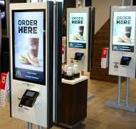

REDESIGN:

